Unit Plan
Title: What is your inheritance?

CONTEXT
Grade Level: 5th grade
Average Class Size: 24 students
Length of Class Period: 50 minutes

UNIT OVERVIEW

Big Idea/Theme/Topic for Inquiry:
Inheritance

Description of the Big Idea/Theme/Topic for Inquiry:
Students will explore what inheritance means to them and think about what they will inherit in their life. This can be heirlooms, culture, history, or stories.

Relevance for Learners:
This unit is relevant for learners as it pulls in objects used in their everyday life, family history, and pop culture references into their art making. The learners I teach are diverse which is why I want to incorporate a diverse group of artists as references and inspiration for them. This unit brings in diversity by incorporating Contemporary Native American artists as the provocation of our art project. This unit will allow students to address diverse themes of social and cultural conflicts that are relevant to their lives.

Relevant Contemporary Artists
Chase Kahwinhut Earles- Chase Kahwinhut Earles combines Caddo pottery techniques with modern day objects to bridge contemporary practices with his Native American cultural roots.

Jason Elliot Clark- Jason Elliot Clark is a Native American Printmaker. He explores Algonquin legends and merges it with his personal history and experiences with misinformation about Native Americans.

Christi Belcourt- Christi Belcourt is a Métis visual artist who creates artwork that expresses her respect for Mother Earth and the traditions and knowledge of her people. Her artwork is made with acrylic paint and encompasses floral patterns inspired by Métis and First Nations historical beadwork.

Articles, book chapters, or resources from class that support the approach(es) to art education you are using in this unit:

Ayers (2019) asked in chapter one of his book for the reader to really think about if they should become a teacher. When thinking about if the reader would be a good fit for teaching, Ayers gives them things to keep in mind for being an authentic teacher. This includes active participation in what the teacher encourages the students to do, to be always evolving, to provide support, collaborate, inspire, and affirm students.

Buffington (2014) discussed the importance of multicultural education and its goal of providing students the ability to understand their place in their communities' culture, popular culture, and other cultures. This approach

Buffington and Bryant (2019) highlighted the importance of changing teaching practices to be culturally sustaining and to dismantle the heterosexual White male narrative that dominates schools.

Novak (2025) writes about the importance of Universal Design for Learning. It highlights that all students are different and learn differently. To address this, teachers are encouraged to give a variety of types of instruction and options to support each student. The teacher is motivated to be flexible in the classroom so as to give students choices in their learning.

References
Ayers, W. (2019). About becoming a teacher. Teachers College Press.

Buffington, M. L. (2014). Power play: Rethinking roles in the art classroom. Art Education, 67(4), 6–12. https://doi.org/10.1080/00043125.2014.11519277

Buffington & Bryant (2019) Changing Practice: Culturally Sustaining Pedagogy in Art Education, Art Education, 72:2, 20-25, DOI:10.1080/00043125.2019.1559587

Novak, K. (2025, June 28). If equity is a priority, UDL is a must. Cult of Pedagogy. https://www.cultofpedagogy.com/udl-equity/

TEACHER PERSPECTIVE (What I Value as a Teacher)

Core Commitments
As an art educator, I am committed to providing diverse and contemporary artists and artwork as the basis for my art provocations. I am committed to providing proper support to all of my students and incorporating student-led learning in my classroom. My teaching is also directly influenced and connected to my own artistic practice and inquiries.

Classroom Dynamics Guide
My goals for the classroom are to have a culture of respect between students and teachers. The environment will be positive and nurturing so as to encourage experimentation and learning growth. My classroom will have a routine so that students understand what is expected of them each day and know where to acquire tools and where to clean their materials. My classroom will also provide room for student choice so they can follow their own interests and paths of inquiry.

WHAT WILL STUDENTS LEARN?

National Visual Arts Standards
VA:Re.7.1.5a: Compare one's own interpretation of a work of art with the interpretation of others.

VA:Cr2.3.5a: Identify, describe, and visually document places and/or objects of personal significance.

VA:Cr3.1.5a: Create artist statements using art vocabulary to describe personal choices in artmaking.

VA:Cn11.1.5a: Identify how art is used to inform or change beliefs, values, or behaviors of an individual or society.

Anchor Standard(s):
- Anchor Standard 7: Perceive and analyze artistic work
- Anchor Standard 2: Organize and develop artistic ideas and work.
- Anchor Standard 3: Refine and complete artistic work.
- Anchor Standard 11: Relate artistic ideas and works with societal, cultural, and historical context to deepen understanding

Enduring Understanding(s):
- Individual aesthetic and empathetic awareness developed through engagement with art can lead to understanding and appreciation of self, others, the natural world, and constructed environments.
- People create and interact with objects, places, and design that define, shape, enhance, and empower their lives.
- Artist and designers develop excellence through practice and constructive critique, reflecting on, revising, and refining work over time.
- People develop ideas and understandings of society, culture, and history through their interactions with and analysis of art.

Essential Question(s):
- How do life experiences influence the way you relate to art? How does learning about art impact how we perceive the world? What can we learn from our responses to art?
- How do objects, places, and design shape lives and communities? How do artists and designers determine goals for designing or redesigning objects, places, or systems? How do artists and designers create works of art or design that effectively communicate?
- What role does persistence play in revising, refining, and developing work? How do artists grow and become accomplished in art forms? How does collaboratively reflecting on a work help us experience it more completely?
- How does art help us understand the lives of people of different times, places, and cultures? How is art used to impact the views of a society? How does art preserve aspects of life?

Enduring Understanding to use with Students
- Students will understand that viewing and interacting with art can lead to learning and appreciating others' experiences.
- Students will understand that places and objects in their everyday life can have deeper meaning.
- Students will understand the importance of choice making in art and how choices inform the piece.
- Students will understand that they can explore new perspectives on the world through art.

Essential Question to use with Students:
- How does your life experience influence your art and inspire it?
- How do objects and places have an impact on people’s lives?
- How does constructive feedback from peers help us refine and understand our own art more?
- How does art help us understand other cultures and people?

HOW WILL THIS UNIT BE INCLUSIVE FOR ALL LEARNERS?
How does this unit demonstrate a commitment to culturally sustaining approaches to pedagogy?
This unit demonstrates a commitment to culturally sustaining approaches to pedagogy by including Native American artists to provide diversity and uses a contemporary approach to the curriculum by focusing on contemporary artists to introduce themes.
How did the Case Study Research Inform your Approach to Planning and Instruction?
The case study research informed my approach to planning and instruction as I looked into attention and distraction in the classroom. The case study found that students that are distracted or causing distraction are often motivated by peer approval. Another reason they can be disengaged is because they lack confidence in their abilities or are uninterested in the topic. To combat this, I will try to keep students engaged by choosing interesting topics for projects that are relevant to them. I will also keep them engaged by giving them choices and directly involving them in the learning process. This can be better done by incorporating differentiating instruction and using Universal Design for Learning.
Overview of Plans for Art Experiences

Art Experience 1
Description:
Students will be introduced to Chase Kahwinhut Earles, a Native American who combines Caddo pottery techniques with modern day objects. They will also learn about Caddo pottery and the meaning of the decorative patterns on it. After, students will be challenged to choose an object in their life that has personal meaning to them. Then they will recreate this object in clay and decorate it with patterns that they will design. Their patterns will have ties to their cultural heritage, personal symbols, or inspiration from nature. This project relates to inheritance as they will explore an object they may inherit or an object they will create and pass on for someone else to inherit. It also explores the National Visual Art Standard of objects of personal significance.

Number of Class Periods: 4
Standards:
- VA:Cr2.3.5a : Identify, describe, and visually document places and/or objects of personal significance.
- VA:Re.7.1.5a : Compare one's own interpretation of a work of art with the interpretation of others.
Objectives:
Students will:
- Understand how objects can have personal significance
- Connect objects to the idea of inheritance
- Develop personal patterns and symbols
- Be able to compare interpretations of artwork
Once Sentence Artmaking Prompt
- How can you connect a modern object to the idea of inheritance?
Enabling Constraints (size, materials, processes, time, etc.):
- Size must be no larger than 1x1x1 foot
- Project must be made of clay
- Project must be completed in 3 class periods

Art Experience 2
Description:
Students will be introduced to Jason Elliot Clark who is an Algonquin Printmaker. He is inspired by Algonquin legends and merges it with personal stories from his life along with highlighting misinformation about Native Americans. Students will also learn about linocut printmaking and create their own print inspired by a mythology from their life. This project relates to the idea of inheritance as they will explore a story or mythology that they have experienced. Mythology is a part of culture and the oral tradition or writing of it helps preserve culture. This mythology is something that they have inherited and will explore with their art.

Number of Class Periods: 3
Standards:
- VA:Cr3.1.5a: Create artist statements using art vocabulary to describe personal choices in artmaking.
Objectives:
Students will:
- Learn about preserving culture and stories
- Incorporate family history and cultural mythology into art
- Create a printmaking piece
- Create an artist statement
One Sentence Artmaking Prompt:
- How can you transfer a mythology that means something to you into art?
Enabling Constraints:
- Project must be done with printmaking techniques
- The project must be completed in three class periods.

Art Experience 3
Description:
Students will be introduced to Christi Belcourt, a Métis visual artist. She creates works inspired by Mother Earth, nature, and the traditions and knowledge of her people. Her artwork mimics the floral pattern beadwork made by Métis and First Nations. Students will create a beadwork inspired piece of art. Students will create their own pattern and symbols inspired by their cultural heritage and nature to fill the page. This experience relates to the idea of inheritance as students will be creating patterns and symbols that reference their cultural heritage and personal inspirations from nature.

Number of Class Periods: 3
Standards:
- VA:Cn11.1.5a: Identify how art is used to inform or change beliefs, values, or behaviors of an individual or society.
Objectives:
Students will:
- Create a Native American beading inspired piece of work
- Create a pattern based on personal symbols and inspiration
- Understand how art is used to inform and change beliefs
One Sentence Artmaking Prompt:
- How can you create a beaded inspired piece of work that tells a story about your inheritance?
Enabling Constraints:
- Work must fit on a 12x18 in. piece of paper or smaller
- Project must be completed in 3 class periods

Artist Information
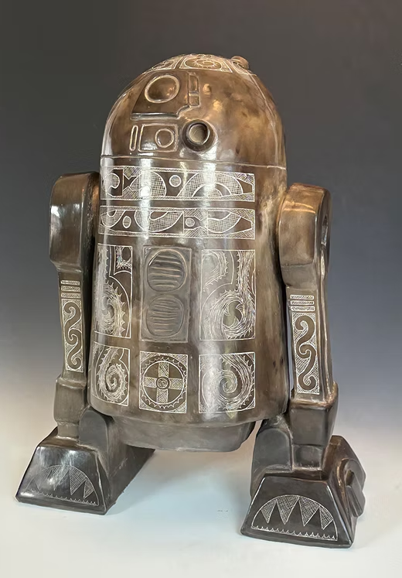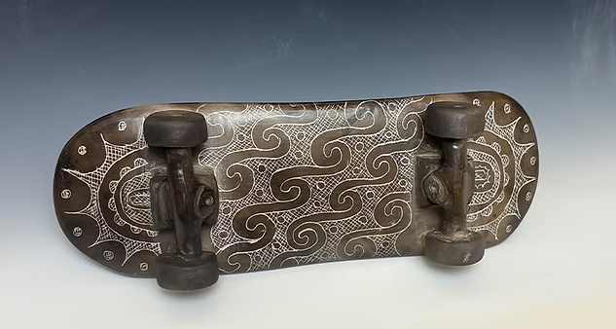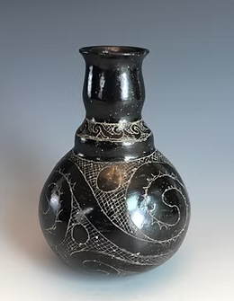
Keeper of the Seeds of Knowledge Caddo Effigy Skateboard 01 Small double shoulder traditional Caddo bottle
Chase Kahwinhut Earles
From 800 AD to the 1700's Caddo tribal pottery was an incredible and well-known tradition in the North American SouthEast traded far and wide even to France and Spain. Knowledge of this great cultural history disappeared as the Caddo tribe consolidated and was decimated from conquistador’s diseases and colonialism. Our last Caddo potter, a matriarch of my tribal namesake, stopped making pottery around 1908 and our tradition was almost lost. Through my work I hope to bring that unsung ceramic legacy back to the light.
Most people don’t get to see our ancient pottery because most all of our ancestral pottery was used at the end of its life as a burial offering. In that way, most of these culturally sensitive pieces cannot be put on display for the public to see. The most important thing to me is to faithfully and respectfully capture the skillfulness and intricate details of our tradition in order to bring to the public’s admiration our specific tribe’s identity.
Because of that I found it important to use the same methods and materials my ancestors would have used with little compromise. Using these traditional methods by digging my own clay, hand gathering the mussel shell I put into the clay, hand building, burnishing with a rock, pit firing the unfired pottery in an open ground fire, and engraving the designs after the pot is fired is important to capture the soul and the essence of our ancestral style and identity.
However, I also feel very deeply that our tribe’s representation and communication through the design and creation of pottery would have evolved over time with the introduction of new situations and environments. For that reason, I also strive to present a new ceramic and sculptural interpretation from my own experiences and as my own artist but as an ambassador to my Caddo tribe and its ancient cultural identity.

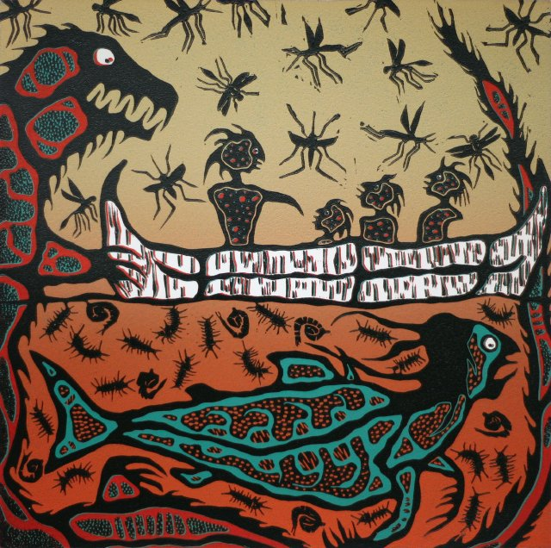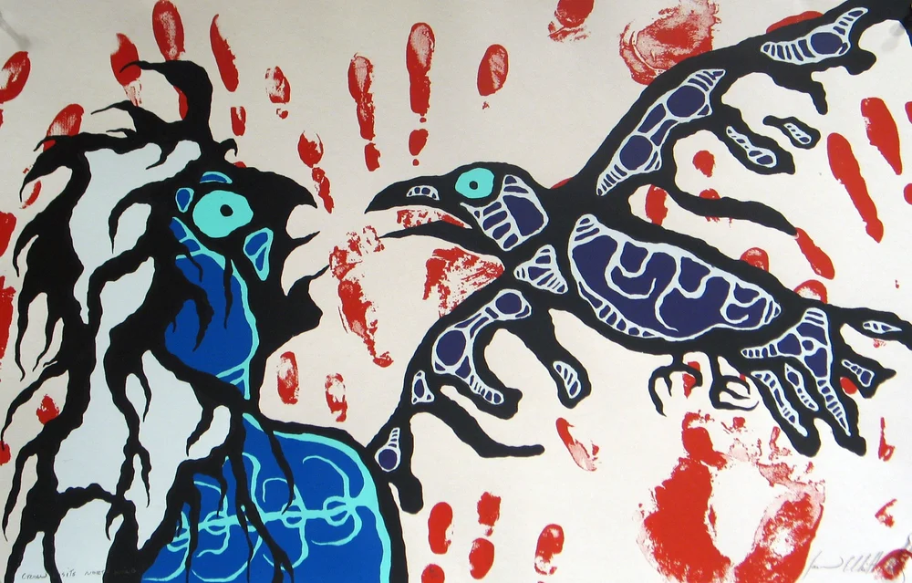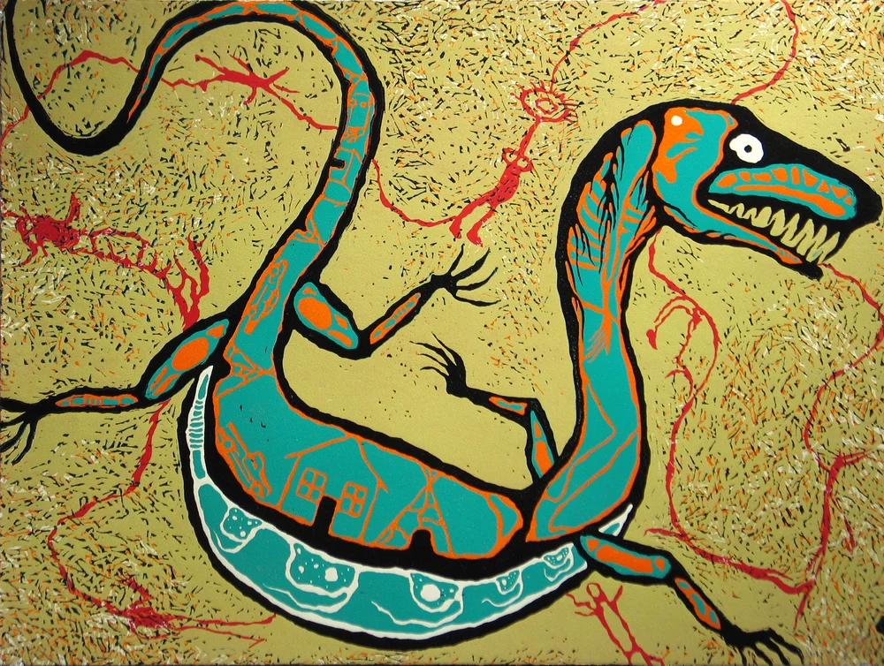
measles, mosquitoes, mississippi & mishipeshu crow visits north wind bad spirits around the house
Jason Elliot Clark
In his work, Clark explores Algonquin legends mixed with personal stories and misinformation about Native American Indian culture today.
“My work is rooted in the traditional teachings and beliefs of my ancestors and the erroneous teachings and beliefs of western society about Native Americans. The subjects portrayed in my art are from personal experiences and the legends of my Algonquin heritage. I am also interested in what people are being taught about Native Americans by western culture through parents, teachers, textbooks, films, television, cartoons, consumer advertisements, products, and other transmitters of misinformation. My work deals with subjects that I have observed or experienced firsthand. These are the stories that have shaped and formed my life. They illustrate how I see the world around me and how I have learned to respect it. The images and stores in my work are reflections or parts of me.” – Excerpted from Artist’s Statement, 2006

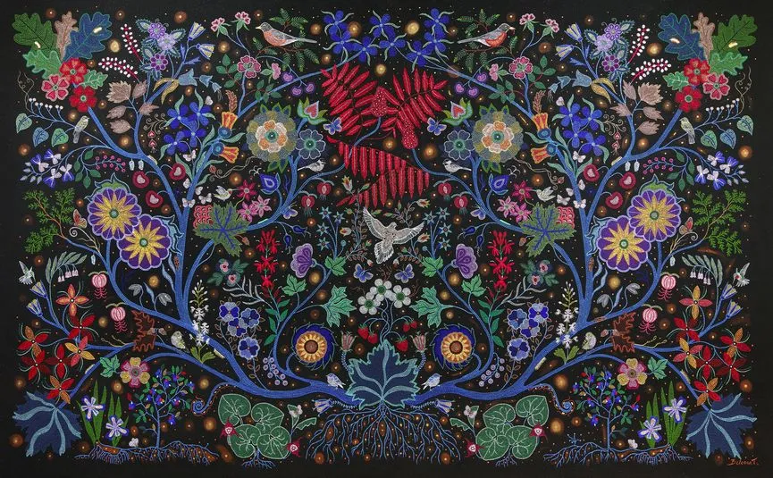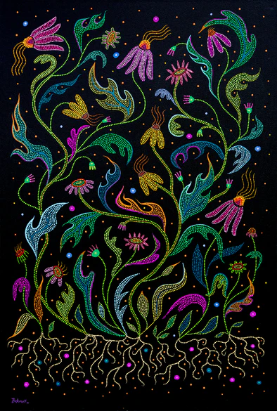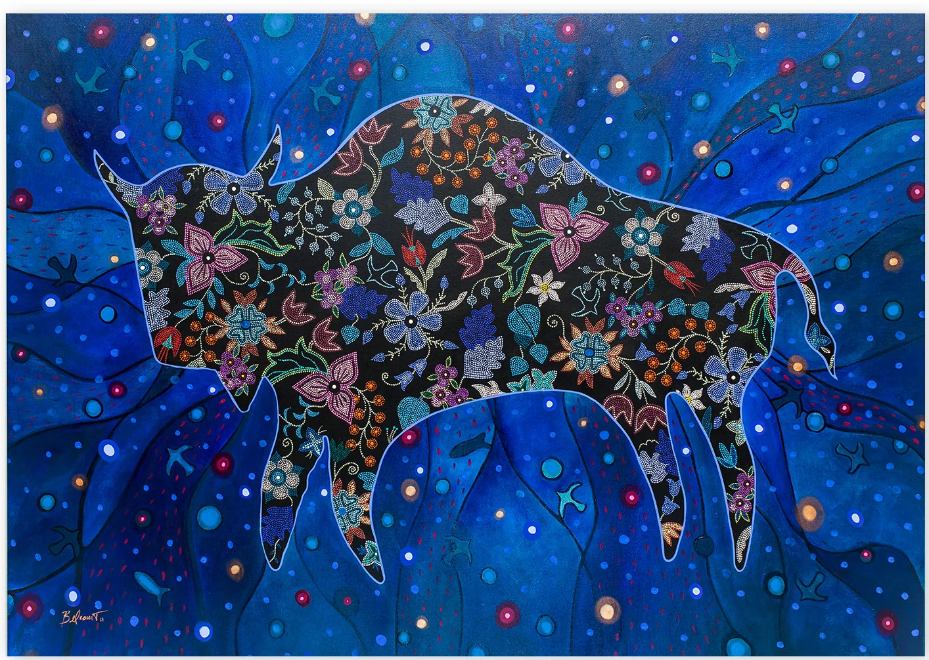
This Painting is a Mirror Echinacaea The Earth is my Government
Christi Belcourt
Christi is a visual artist with a deep respect for the traditions and knowledge of her people. Like generations of Indigenous artists before her, she celebrates the beauty of the natural world while exploring nature’s symbolic properties. Following the tradition of Métis floral beadwork, Belcourt paints in dots and uses the subject matter as metaphors for human existence to relay a variety of meanings which include concerns for the environment, biodiversity, spirituality and awareness of Métis culture.
Christi has also organized several large national community-based projects of note including Walking With Our Sisters (2012-2021) which was a national touring commemoration in honour of Murdered and Missing Indigenous women, girls and two-spirit people, the Willisville Mountain Project (2010-2013) a community arts project which resulted in Vale Mining agreeing to not quarry the mountain. For the last 5 years, Christi and Isaac Murdoch (within their group Onaman Collective) have created artworks and worked on a long list of community organizing around environmentalism and Indigenous languages and cultural revitalization. They, with others, formed Nimkii Aazhibikong.
Christi donates the proceeds from her collaborations and awards to Nimkii Aazhibikong, the year-round Indigenous language and traditional arts camp started in 2017. The camp is committed to the revitalization of Anishinaabemowin language, the arts and sustainable living practices based on foundational cultural knowledge.

References
Christi Belcourt. Christi Belcourt Art. (n.d.). https://christibelcourt.ca/pages/about
Jason Elliott Clark: Myths and legends. MAGDA. (2023, July 13). https://magdamt.org/traveling-exhibitions/exhibitproposalform/jason-elliot-clark-prints-from-the-mam-collection/
Kahwinhut Earles , C. (n.d.). About. Caddo Pottery. https://www.caddopottery.com/about

Plan for Art Experience 1

Title: Clay Heirloom

WHAT WILL STUDENTS LEARN?

National Visual Arts Standards
Anchor Standard(s):
Anchor Standard 7: Perceive and analyze artistic work

Enduring Understanding(s):
Individual aesthetic and empathetic awareness developed through engagement with art can lead to understanding and appreciation of self, others, the natural world, and constructed environments.

Essential Question(s):
How do life experiences influence the way you relate to art? How does learning about art impact how we perceive the world? What can we learn from our responses to art?

Enduring Understanding to use with Students
Students will understand that viewing and interacting with art can lead to learning and appreciating others' experiences.

Essential Question to use with Students:
How does your life experience influence your art and inspire it?

Standards
- VA:Cr2.3.5a : Identify, describe, and visually document places and/or objects of personal significance.
- VA:Re.7.1.5a : Compare one's own interpretation of a work of art with the interpretation of others.

Objectives:
Students will:
- Understand how objects can have personal significance
- Connect objects to the idea of inheritance
- Develop personal patterns and symbols
- Be able to compare interpretations of artwork

WHAT WILL STUDENTS DO (THE PROVOCATION)?

Once Sentence Artmaking Prompt
How can you connect a modern object to the idea of inheritance?

Enabling Constraints (size, materials, processes, time, etc.):
- Size must be no larger than 1x1x1 foot
- Project must be made of clay
- Project must be completed in 3 class periods

Evidence of Learning/Understanding:
Students will:
- Use ceramics to make a 3D sculpture
- Learn coil pot technique
- Be able to discuss the work of Chase Kahwinhut Earles
- Create symbols and a pattern based on on personal experiences

Instructional Activity (discussion, feedback, presentation, etc.):
The instructional activity will begin with a picture of Chase Kahwinhut Earles Caddo Effigy Skateboard 01 presented on the board. Students will be put into groups of 4 to discuss the piece and interpret its meaning. After, one person from each group will present their findings to the class. Next, the teacher will give a powerpoint presentation about Chase Kahwinhut Earles, Caddo Pottery, and the idea of inheritance. The teacher will also give individual feedback to students during the making process.

Important Vocabulary and Definitions (defined appropriately for grade level):
- Pottery- Pots, dishes, and other articles made of earthenware or baked clay. Pottery can be broadly divided into earthenware, porcelain, and stoneware.
- Caddo Pottery- Caddo pottery refers to the traditional pottery of the Caddo people, made from local clay and used for both utilitarian purposes like cooking and storage, and ceremonial or symbolic uses. It is known for its unique styles, such as engraved bottles and carinated (sharply angled) vessels, with designs often representing elements like the sun and water.
- Inheritance- to receive from an ancestor. This can be a right, title, or possession.
- Heirloom- An heirloom is something valuable or sentimental that has been passed down for generations.

Differentiation and Universal Design for Learning:
Students will be given a variety of types of instruction for different learning needs. Students will engage in a discussion about artwork, be shown a powerpoint with information, will be shown inspiration images, will be given a clay demonstration, will be allowed to experiment with clay, and be given verbal feedback on their pieces. Students with disabilities will be given alternative tools or mediums to help them create art.

SUPPORTING ELEMENTS FOR THE ART EXPERIENCE

Classroom Environment:
The classroom will have Native American and Ceramic pieces of art displayed for inspiration. There will be a variety of tools at each table group to encourage experimentation. All additional tools and materials will be organized in drawers and labelled with text and pictures.

Preparation:
Materials:
- Clay
- Clay tools
- Wooden rib
- Wire tool
- Needle tool
- Sculpting tools
- Wooden skewers for carving designs
Classroom Staging:
- Each table will have four sets of clay tools for each student to use.
- Each students areas will need a cup of water
- The teacher will need to precut clay into smaller pieces.

Resources:
- Presentation-https://www.canva.com/design/DAG6AfrqwUM/sq86XaubP8LRfZDHnMDxDQ/edit?utm_content=DAG6AfrqwUM&utm_campaign=designshare&utm_medium=link2&utm_source=sharebutton
- Resource about Contemporary Caddo Pottery- https://contemporarymakers.blogspot.com/2015/08/caddo-pottery.html
- Resource about Caddo Pottery history- https://www.texasbeyondhistory.net/tejas/clay/tradition.html
- Chase Kahwinhut Earles’ Website- https://www.caddopottery.com/about

Clean-up Procedures:
- Students will put their tools back in the containers they belong in
- Students will put scrap clay will be put into a bag to be wedged
- Students will wipe down their areas with sponges
- The teacher will put all projects onto wooden boards and wrap in plastic to keep them moist
- Once the pieces are finished and dry, teacher will put the pieces into the kiln

ASSESSMENT
Formative assessment
- The teacher will walk around the classroom giving individualized feedback to each student during the making process.

Summative Assessment
- The teacher will grade a rubric for each student on their project

LEARNING PLAN
(STEPS FOR IMPLEMENTING THE ART EXPERIENCE)
Day 1
The Teacher will: | The Students will:
Prior to the Experience
Invite students in and have them get ready for the project  Put the presentation on the whiteboard and present the slides | Students will put away anything they bring with them and have a seat.
Instructional Time (time: 5-10 minutes)
- “Today we are going to start a project called Clay Heirloom.”  “We are going to start by working in groups to interpret this piece of art on the board. After five minutes, each group will present what their group came up with.”  “Things you can think about while discussing are:  What do you see?  What color is the art?  What material is it made of?  What elements are there in the piece?  What might that pattern represent?  Do the symbols have meaning?  How does it make you feel?  What do you think the artist was thinking?” | Students will participate in introductory inquiry discussion.  Students may answer that they see a skateboard, the piece is made of clay, there are patterns on it, that the symbols might represent nature, that it makes them feel sad, or that it makes them feel happy. They may think the artist wanted to replicate a skateboard because he likes skateboarding.
- “The artist of the piece we just interpreted is named Chase Kahwinhut Earles. He is a Native American from the Caddo Nation. The Caddo Nation used to live in the area where Texas, Oklahoma, Arkansas, and Louisiana meet.”  “Their population was diminished by 95% due to a few factors. European settlers brought diseases that their bodies were not equipped for, they were forced to relocate by the American government, and they lost people at war to neighboring hostile tribes.” | Students will listen while the teacher presents information about the artist and about the Caddo Nation.
- “One of the things the Caddo are most known for are their pottery. They used the coil pot technique to create their pieces and used river pebbles to burnish them making them shiny. Then they would decorate it by carving designs and filling the carved lines with pigment so they stand out.”  “What are some decorations you saw on the skateboard art piece?”  “They were decorated with various designs including:  -cross hatchching  -spirals  -featheres  -serpants  And symbols inspired by nature:  -water  -fire  -the moon  -the sun  And some were inspired by origin story of the Caddo people” | Students may answer that they saw lines, swirls, sun rays, circles, crosshatching.
- “Some pieces were used for everyday needs like cooking and storage. Others were ceremonial pieces.”

“The reason we don’t have many pictures of Caddo pottery is because many are sacred and buried with their dead.”
Making Time (time: 20-25 minutes)
- “We are going to make a clay piece inspired by Chase Kahwinhut Earles.”  “We are going to start by creating our own pattern made of personal symbols to decorate our clay pieces. These symbols can be things that you feel represent you, are inspired by your values, your interests, or inspired by the nature around you.”  “How do we turn our symbols into a pattern?” | Students may answer that they need to repeat the symbols to create a pattern.
- “You can begin sketching out your ideas for symbols and then combine them to make patterns.”  - “If you have finished creating your symbols and patterns then you can start brainstorming for the next part. You are going to create a clay version of a modern object that means something to you.”  “Think of some ideas for objects and you can start deciding how you want to decorate it with your pattern.” | Students will use their sketchbooks to brainstorm symbols and patterns  Students will use their sketchbook to brainstorm an object to make out of clay. They will also start figuring out how they want their pattern to decorate the piece.
Sharing and Closure (time: 10 minutes)
- “You have five minutes to finish up what you are working on.” | Students should start getting to a stopping point for the day.
- “While you are finishing up, take a minute to think about the symbols you made and what they mean to you.”  “Next class we will be picking a modern object to recreate out of clay. This object needs to have some meaning to you so take some time to think of ideas for it after class.” | Students should think about the personal meaning behind their symbols.  Students will think about what object they would like to recreate.
- “It’s time to clean up. Put your pencils and sketchbooks away and line up at the door.”

Day 2
The Teacher will: | The Students will:
Prior to the Experience
Invite students in and have them get ready for the project  Put the presentation on the whiteboard and present the slides for day 2 | Students will put away anything they bring with them and have a seat.
Instructional Time (time: 5-10 minutes)
- 1“Today we are going to continue our Clay Heirloom project.”  “As a reminder, here are some pictures of our inspiration.” | Students will sit and listen to the presentation.
- “We are going to learn how to work with clay.”  “The first technique is called the slip and score method or the scratch an attach method. You use this method to attach pieces of clay together. If you do not do this method, the pieces will fall off from each other when they are put in the kiln. You are going to use your needle tool to make a bunch of scratch marks on your piece of clay wherever the two pieces are going to touch. Then you will make scratch marks on the other piece of clay. Next you are going to add your slip. Slip is a mixture of clay and water that forms a paste that will be used as glue. Then you can push and wiggle the two pieces together so that they are really stuck.” | Students will sit and watch demonstrations.
- “The next method we are going to use is called the coil method. This is the method that the Caddo Nation used to create their pieces of pottery. When we make our pieces, we are going to use this method because we want our pieces to be hollow so that they can dry out properly and not crack. We’ll begin by grabbing a chunk of clay and squishing it into a log shape. Then we are going to use our palms to gently push down and roll the piece of clay. The longer your rolls, the better your coil will turn out.”

- “Once we have our coil, we're going to add it to our base. I just rolled out a piece of clay and cut out the shape I wanted it to be. We are going to scratch and attach or slip and score our pieces together so that the coil goes all along the outside of our base. Once we get around the base then we will lift our coil up on top of our first layer starting to spiral it up. You can use as many coils as you need. All you need to do is attach the new coil to the last coil on the pot.”  “Does anyone have any questions?” | Students may ask some clarifying questions.
Making Time (time: 20-25 minutes)
- “Start off by brainstorming what modern object you would like to make out of clay. Remember that this object needs to have some sort of meaning to you. Then you can use your sketchbook to plan how you are going to make it with the coil pot method” | Students will brainstorm in their sketchbooks.
- “Then you can begin using your clay to start making the piece. We are going to work on our objects for two days and then on the third day we are going to add our patterns and symbols on to it” | Students will use the coil pot method to make their objects.
Sharing and Closure (time: 10 minutes)
- “You have five minutes to finish up what you are working on.” | Students should start getting to a stopping point for the day.
- “While you are finishing up, think about why you chose the object you are making and how will the meaning of it change when you add the patterns to it. Will it tell a story about you?” | Students will think about why they chose their objects and how the meaning will change when the patterns are added.
- “Ok, it is time to clean up. Put your tools back in the containers at the center of the table. You are going to put your projects on to a board and wrap plastic around it so that it does not dry out before next class. Make sure all of the edges are tucked in so no air can get it. Please put those projects on the shelves. You can dump out your water in the sink and then use a sponge to wipe up your area. Lastly, make sure to wash your hands.” | Students will clean up their materials and areas.
Day 3
The Teacher will: | The Students will:
Prior to the Experience
Invite students in and have them get ready for the project.  Put the presentation on the whiteboard and present the slides for day 3. | Students will put away anything they bring with them and have a seat.
Instructional Time (time: 5-10 minutes)
- “Today we are going to continue our Clay Heirloom project.”  “But, first we are going to have a little discussion about the name of the project” | Students will sit and listen to the presentation.
- “Does anyone know what an heirloom is?”  “Yes, an heirloom is something valuable or sentimental that has been passed down for generations. Another word that we can use for this is inheritance. An heirloom is something that we can inherit.”  “Are there other things that you can inherit besides objects?  “You can inherit a lot of things, the genetics from your ancestors, stories, personality traits, history, and culture.  “Do you think it is important to pass down things? Why?”  “So why do you think Chase Kahwinhut Earles makes his art?” | Students may answer that it is something that is passed down in families.  Students may answer that they can inherit money, genetics, and culture.  Students may answer yes or no. If they said yes then they may say its important to pass down so your ancestors remember and understand your history and culture.  Students may say that he makes his art to pass on his traditions and cultures to others.
- “With the pieces you are making, maybe these can be inherited by your ancestors as a family heirloom and also a way to pass on your story to your ancestors like Chase Kahwinhut Earles”

Making Time (time: 20-25 minutes)
- “We are going to continue making our modern objects out of clay and we're going to try to finish making them today so that we can decorate them next week.”  - “Remember to use the scratch and attach or slip and score method while working” | Students will continue making their objects with the coil pot method
Sharing and Closure (time: 10 minutes)
“You have five minutes to finish up what you are working on.” | Students should start getting to a stopping point for the day.
“While you are finishing up, think about what family heirlooms you know of and what they mean to you. You can even think about asking your family to show you some family heirlooms” | Students will think about family heirlooms
“Ok, it is time to clean up. Put your tools back in the containers at the center of the table. You are going to put your projects on to a board and wrap plastic around it so that it does not dry out before next class. Make sure all of the edges are tucked in so no air can get it. Please put those projects on the shelves. You can dump out your water in the sink and then use a sponge to wipe up your area. Lastly, make sure to wash your hands.” | Students will clean up their materials and areas.

Day 4
The Teacher will: | The Students will:
Prior to the Experience
Invite students in and have them get ready for the project.  Put the presentation on the whiteboard and present the slides for day 4. | Students will put away anything they bring with them and have a seat.
Instructional Time (time: 5-10 minutes)
- “Today we are going to finish our Clay Heirloom project.”  “I’m going to show you one more technique that we are going to use today. Chase Kahwinhut Earles used a technique called burnishing on his pieces. Usually we use a glaze on clay which has glass in it to make it shiny but, you can also burnish a piece to make it shiny. You can use a lot of different tools to do it but Chase Kahwinhut Earles uses the method that the Caddo Nation uses which is taking a river rock and rubbing it on the surface in circles to smooth out the piece. You can try this out on your pots while your working to make it shiny” | Students will sit and listen to the presentation.  Students will watch a burnishing demonstration.
- “We are also going to decorate our pieces by adding our personal symbols and patterns on to the piece today. We are just going to use some wooden skewers to draw our designs on. Make sure that you push hard enough to carve into the piece”
Making Time (time: 20-25 minutes)
- “You can begin getting your projects and tools and working on your pieces.” | Students will work on burnishing and adding patterns to their pieces.
Sharing and Closure (time: 10 minutes)
“You have five minutes to finish up what you are working on.” | Students should start getting to a stopping point for the day.
“While you are finishing up, think about what you’ve created and what you like about it” | Students will think about what they created and what they liked about it.
“Ok, it is time to clean up. Put your tools back in the containers at the center of the table. You are going to put your projects on to your board and put those projects on the shelves. You can dump out your water in the sink and then use a sponge to wipe up your area. Lastly, make sure to wash your hands.” | Students will clean up their materials and areas.

Slideshow for Art Experience
https://www.canva.com/design/DAG6AfrqwUM/sq86XaubP8LRfZDHnMDxDQ/edit?utm_content=DAG6AfrqwUM&utm_campaign=designshare&utm_medium=link2&utm_source=sharebutton

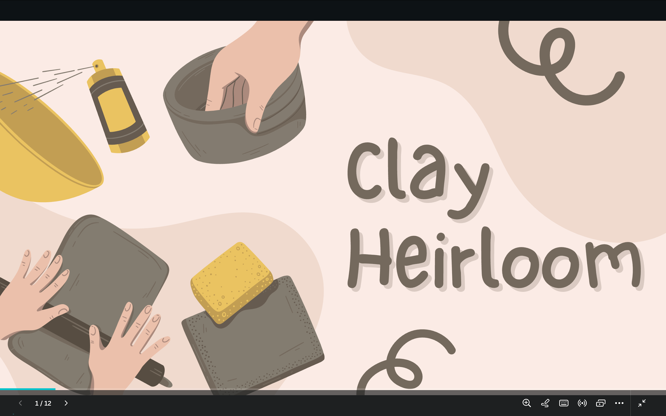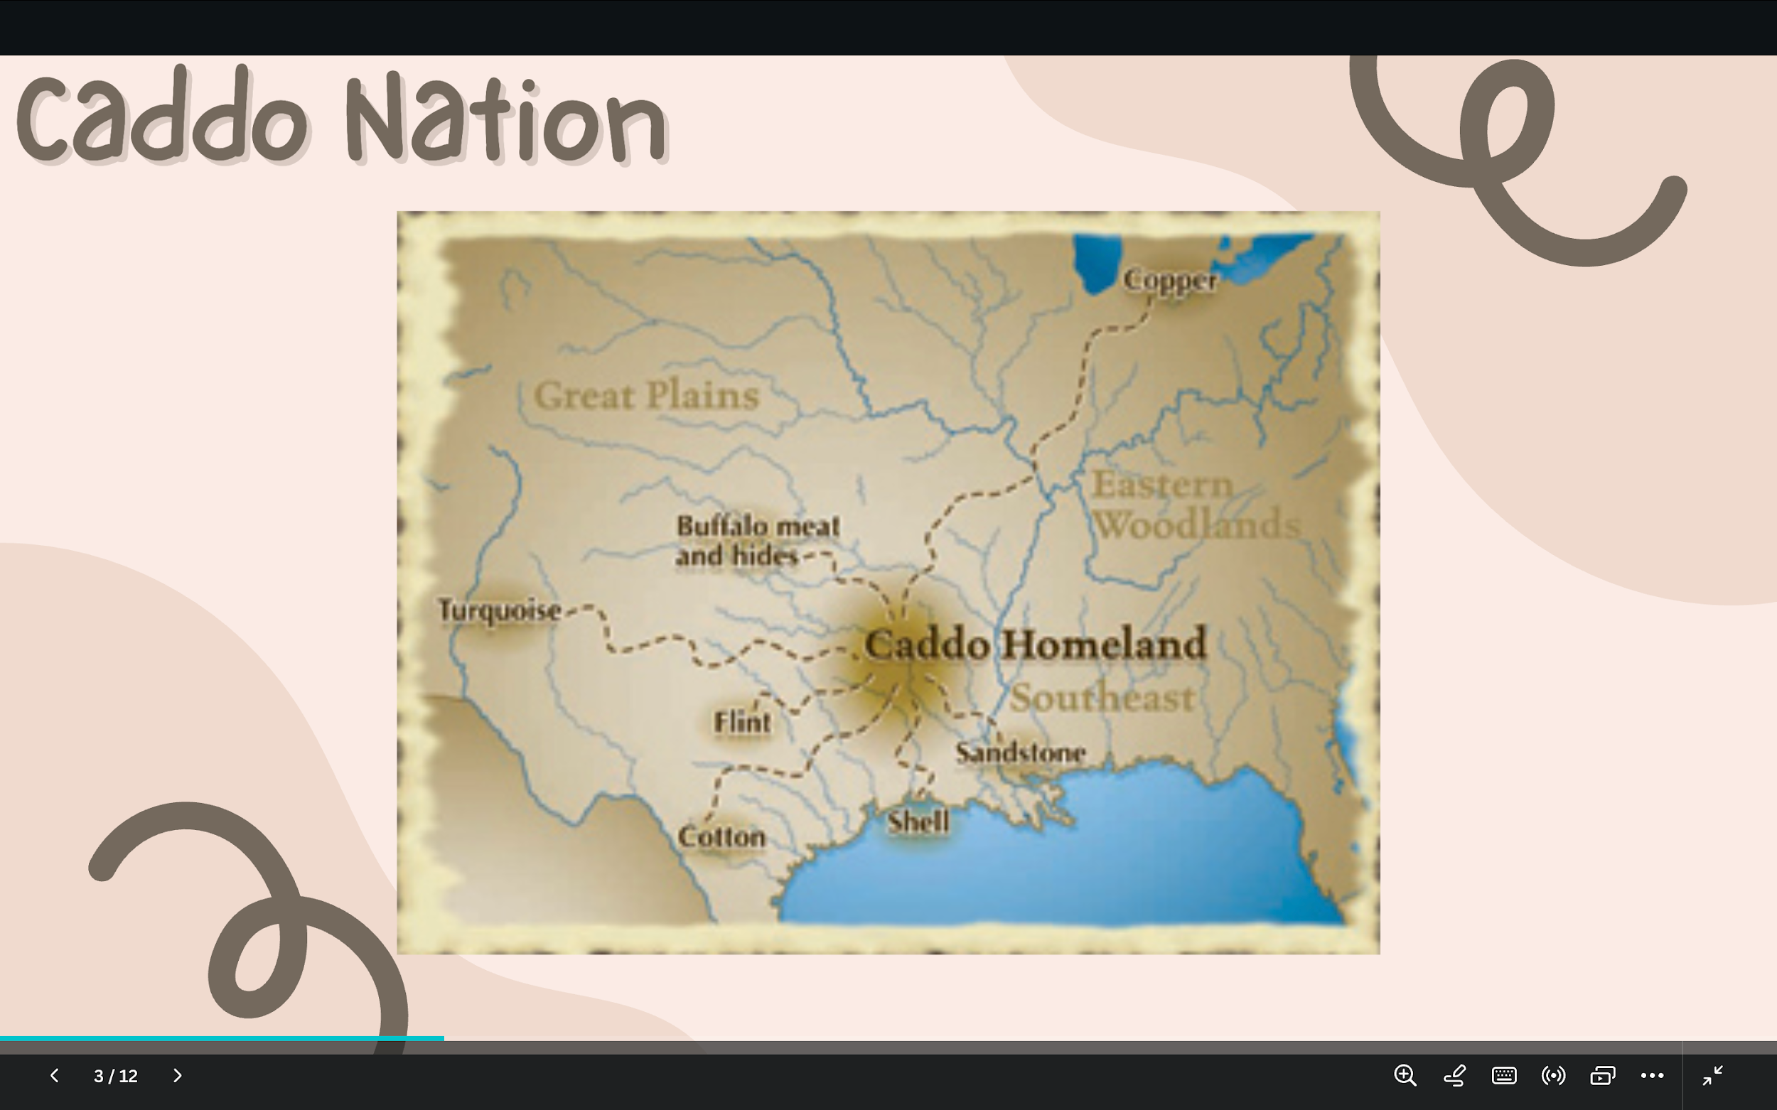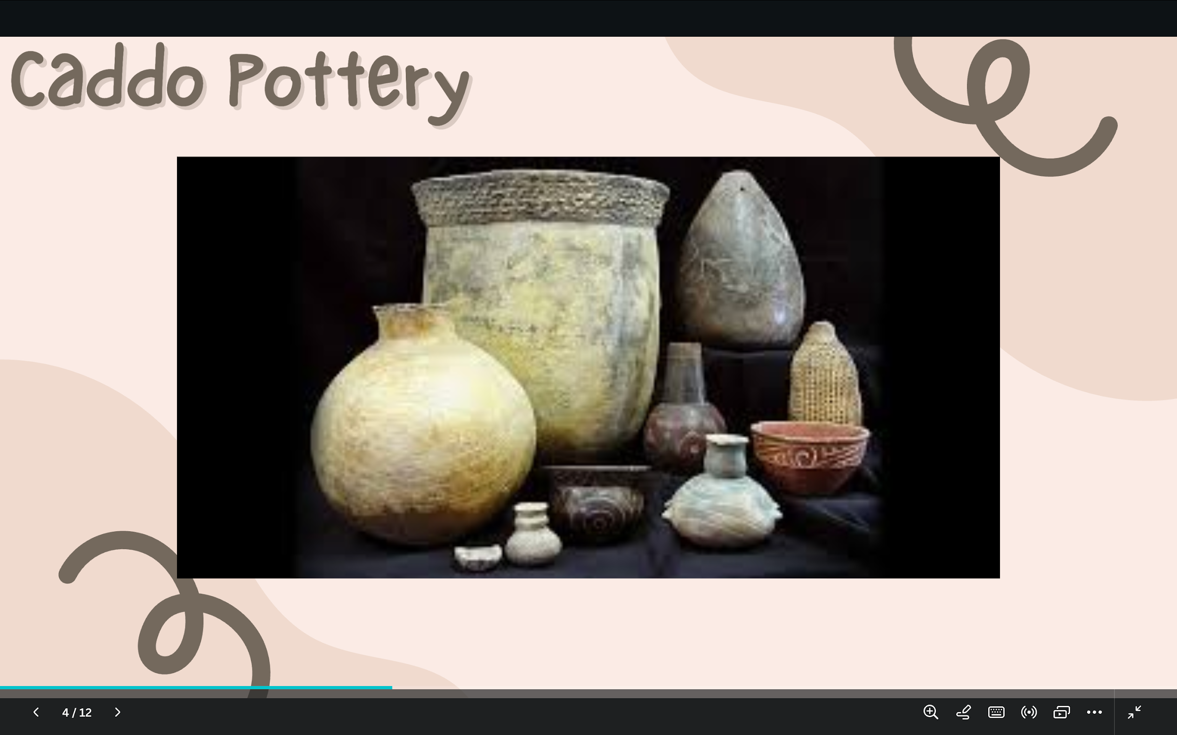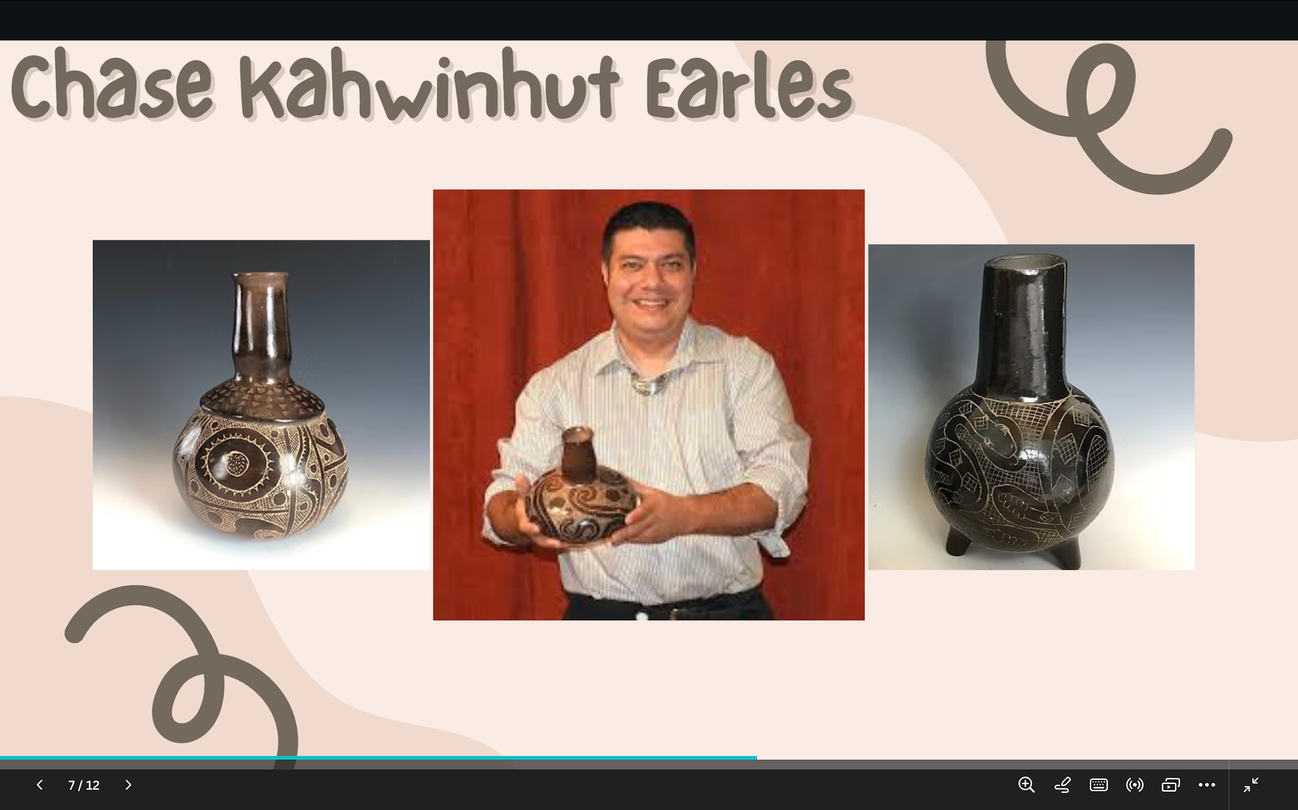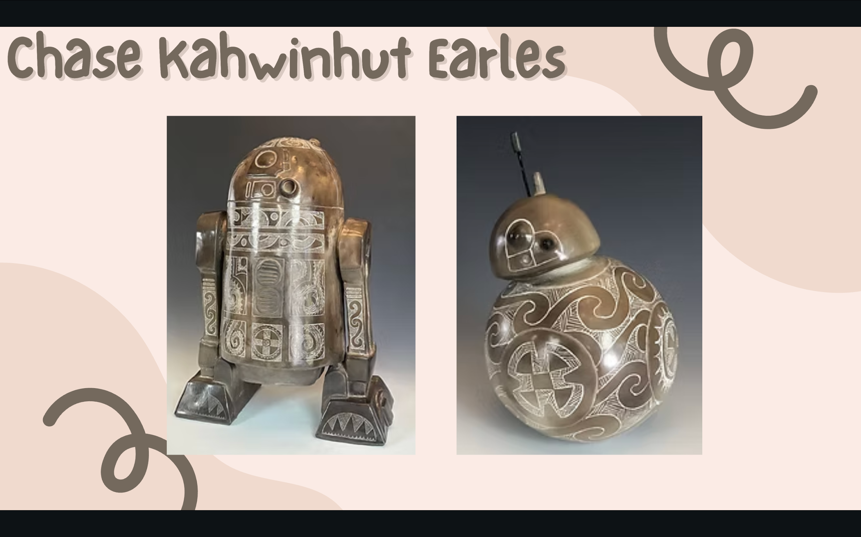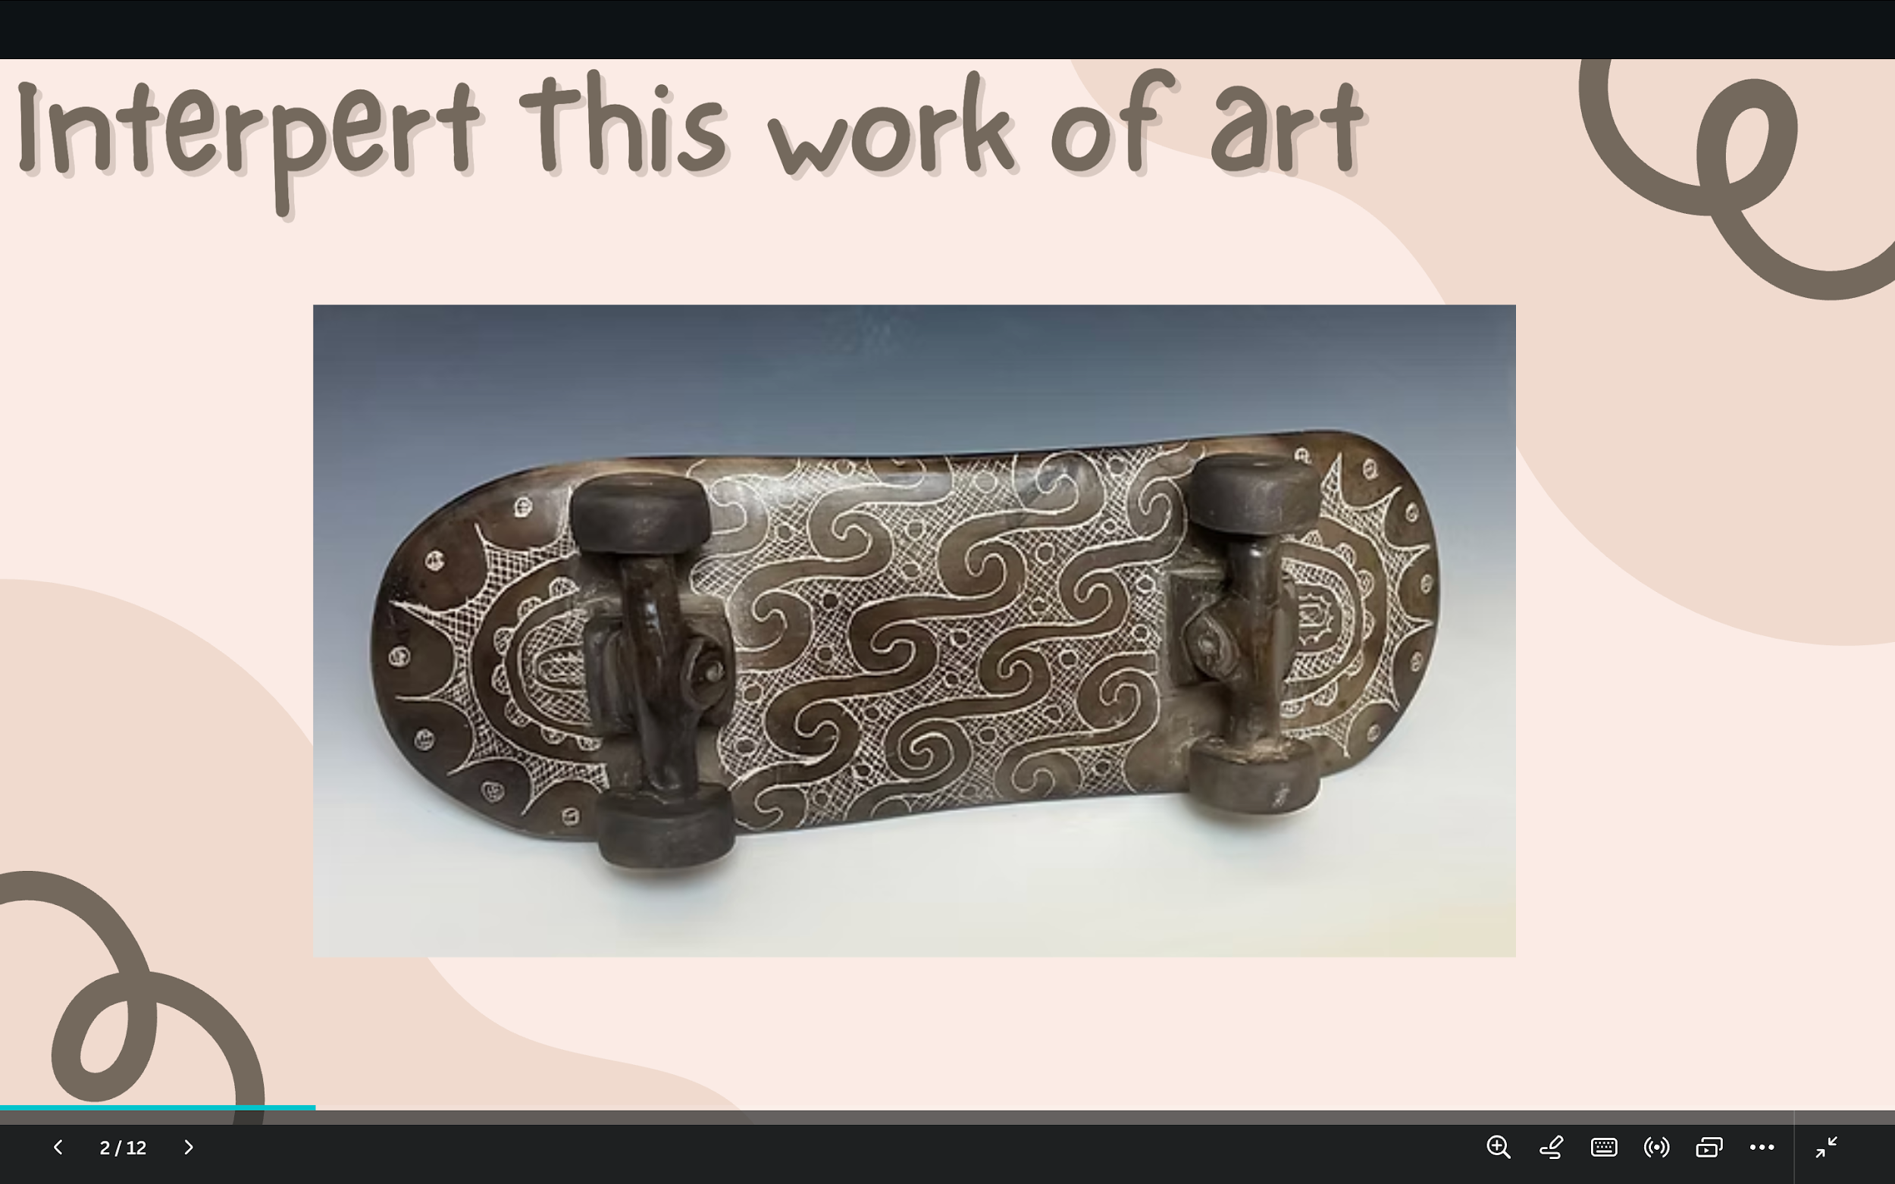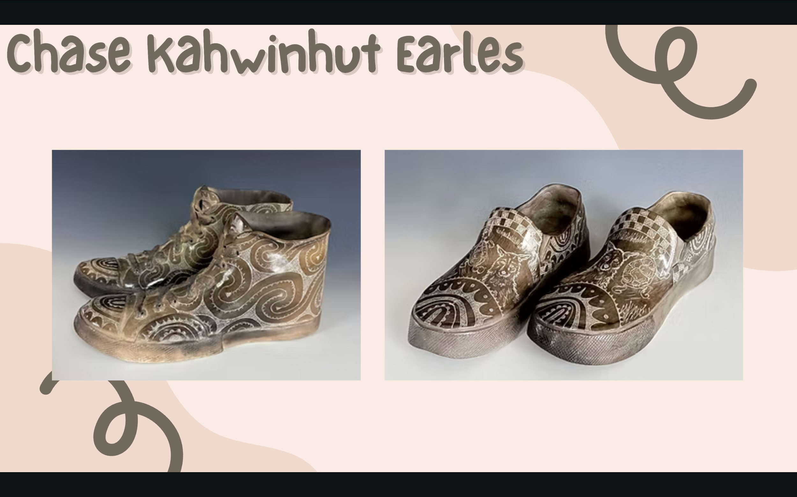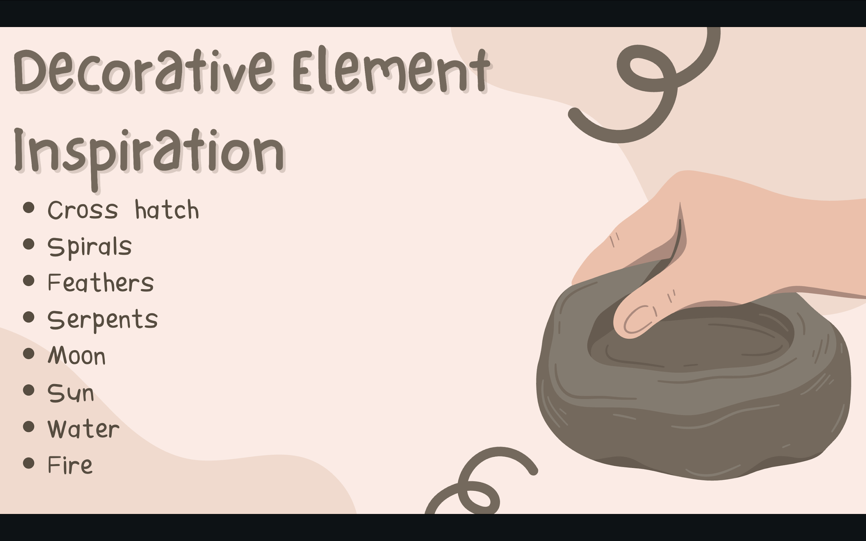
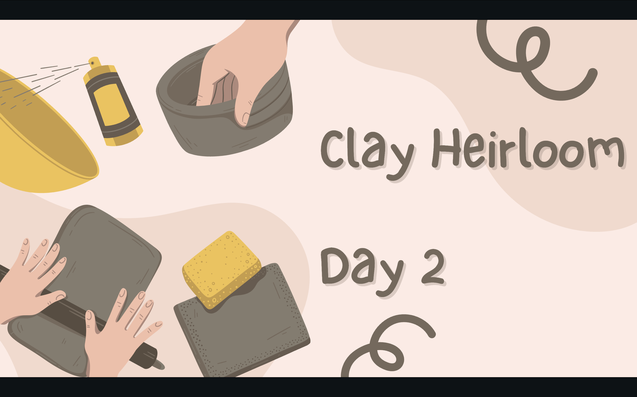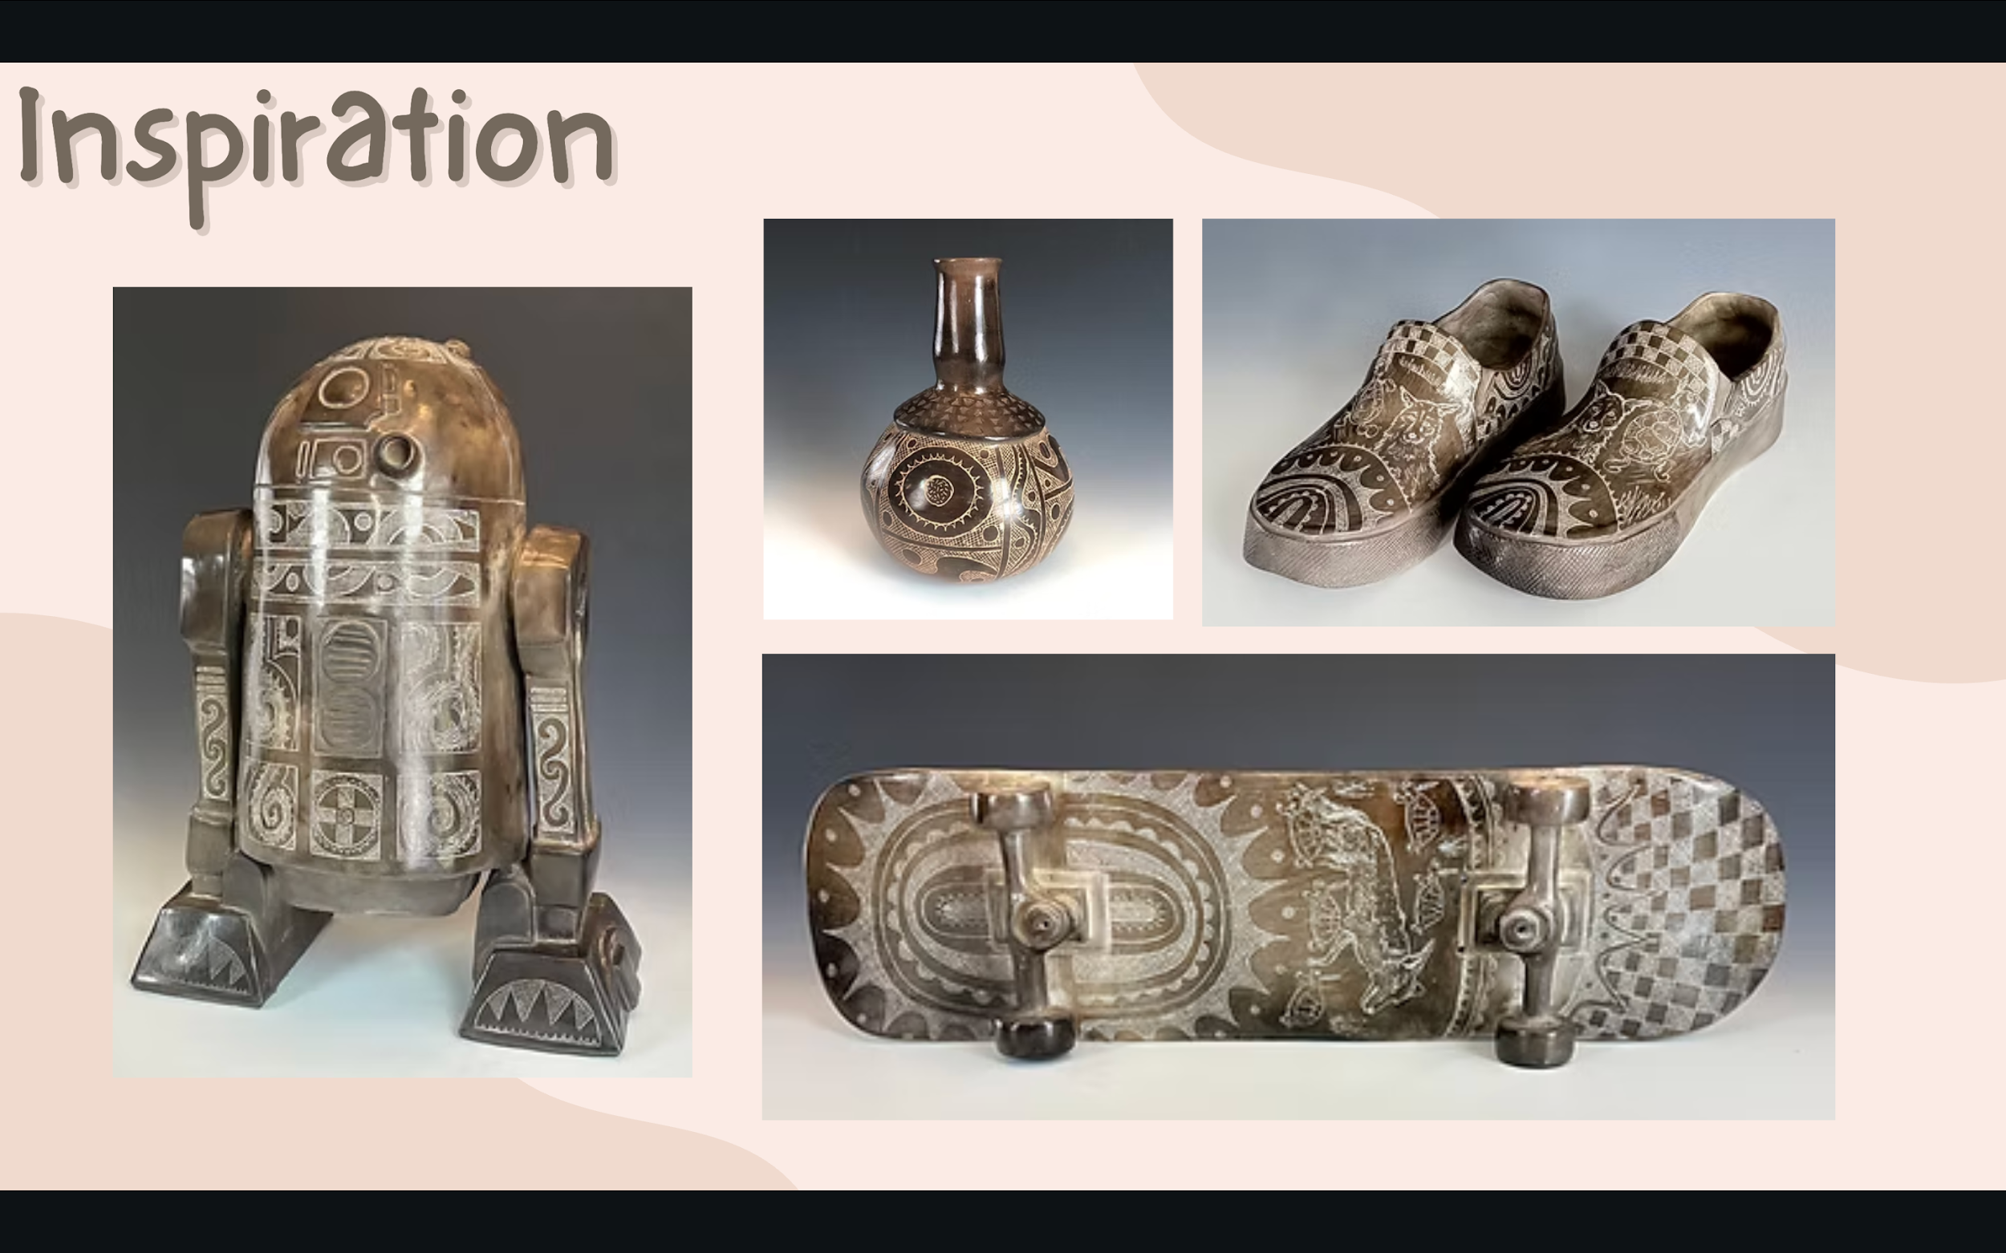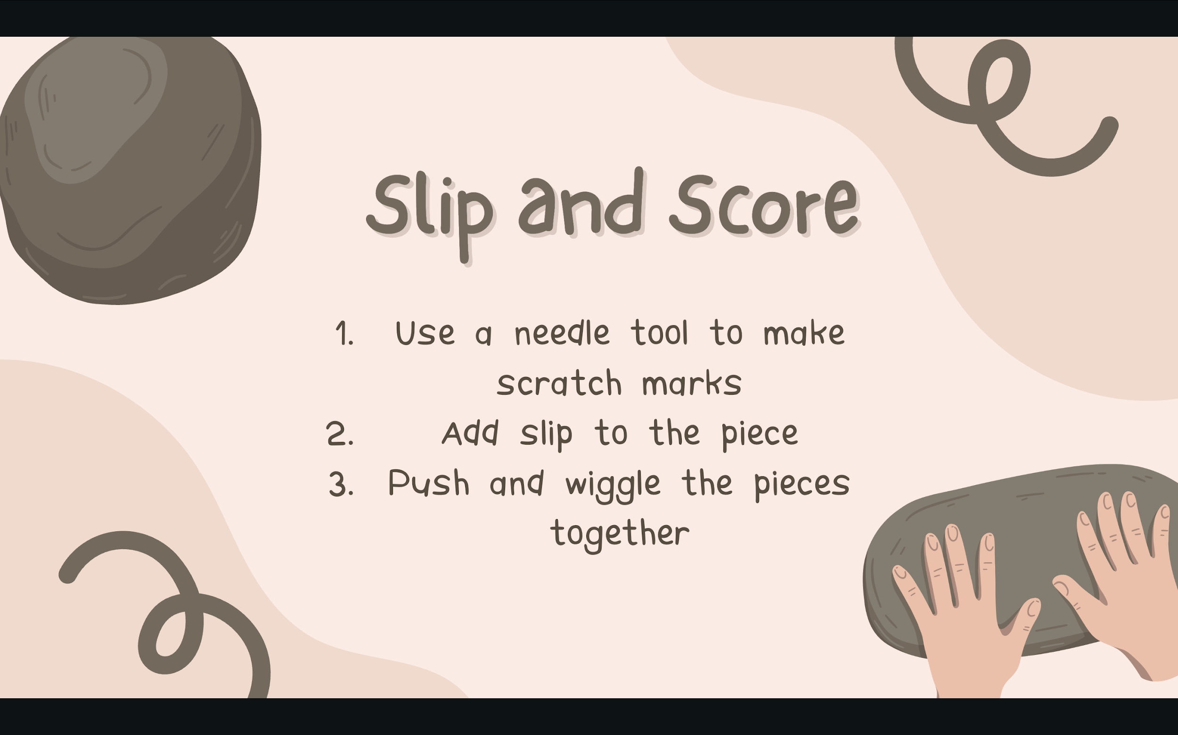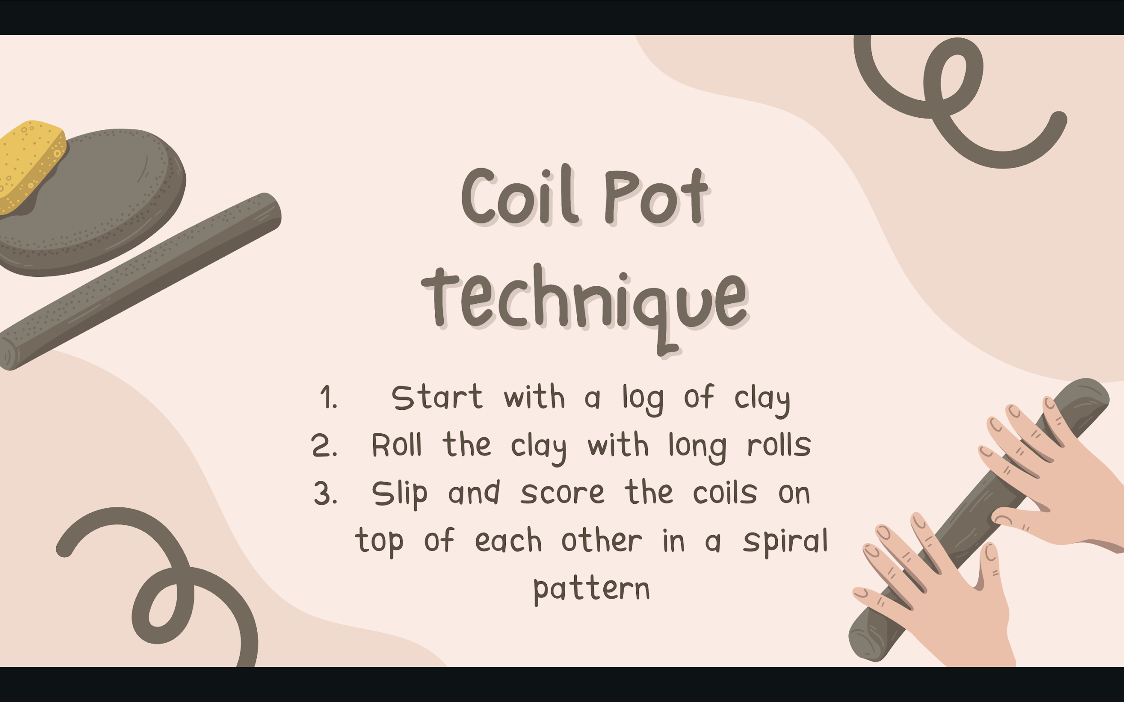
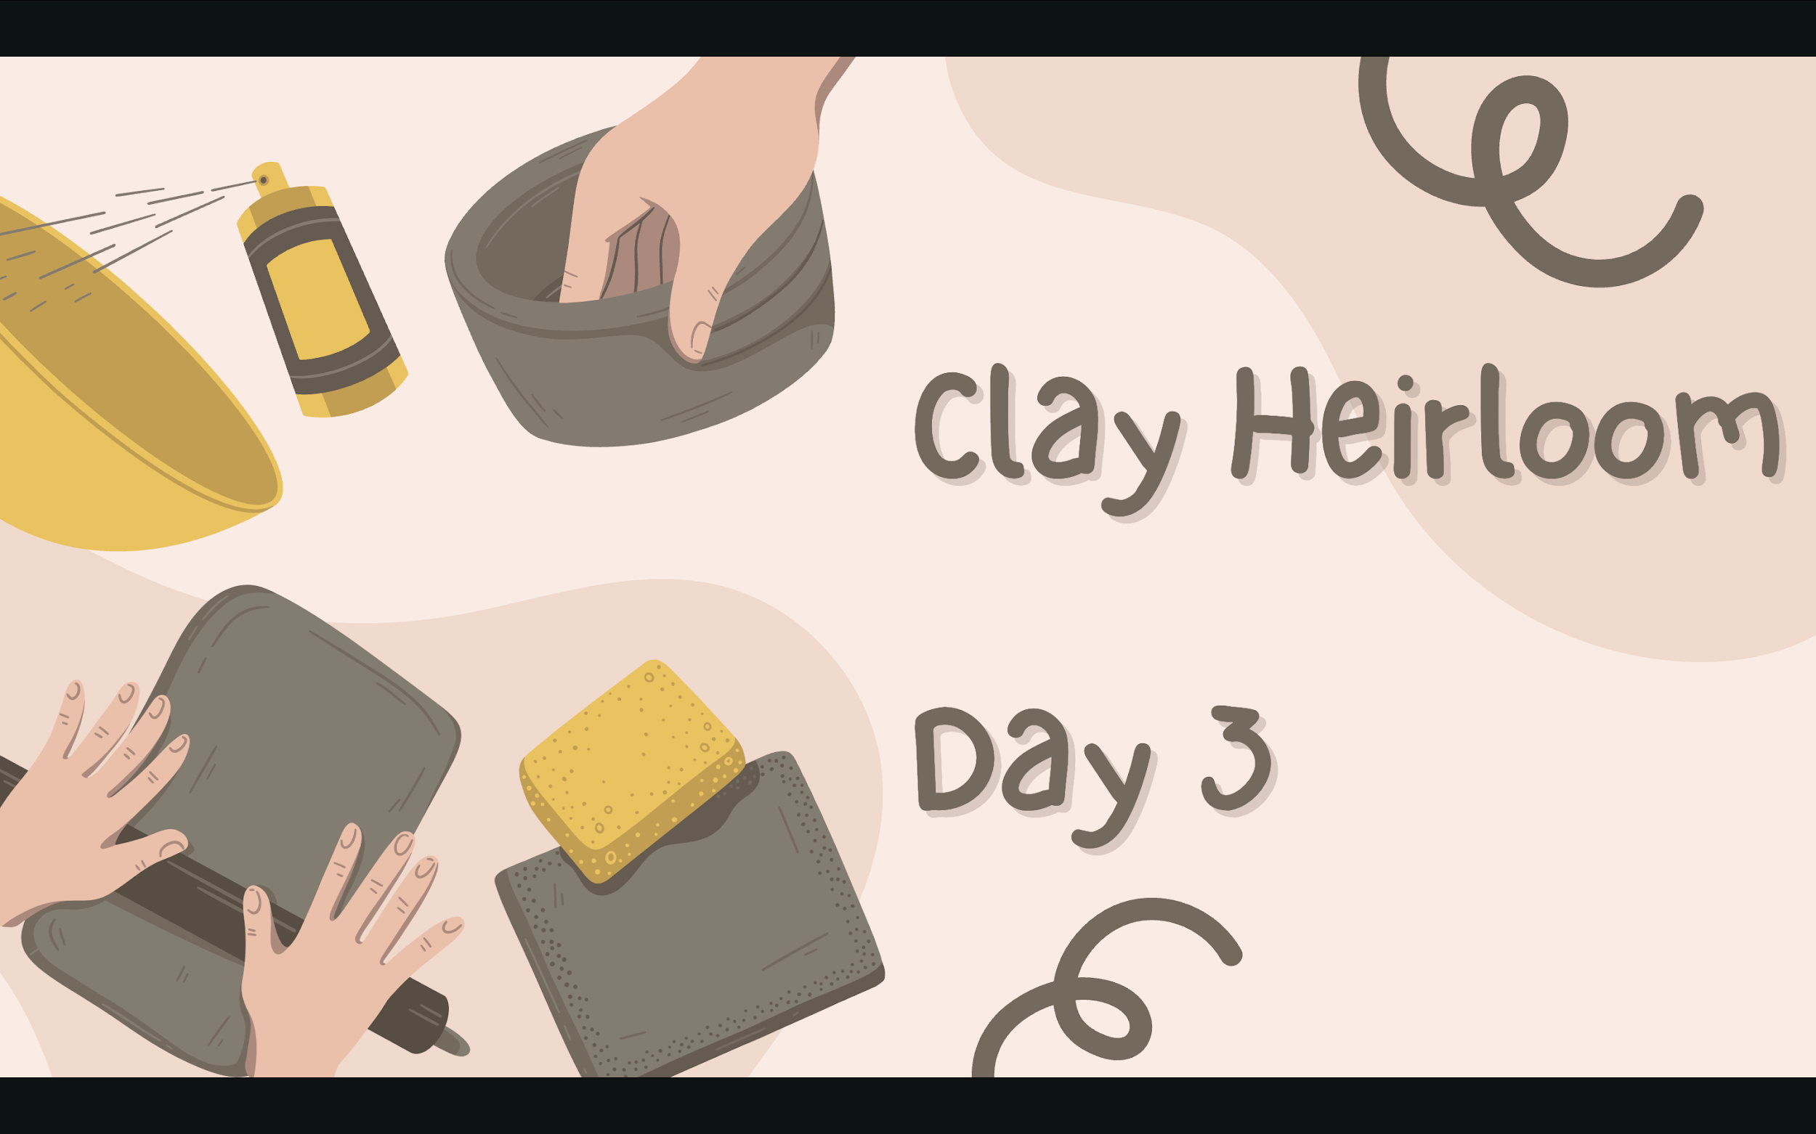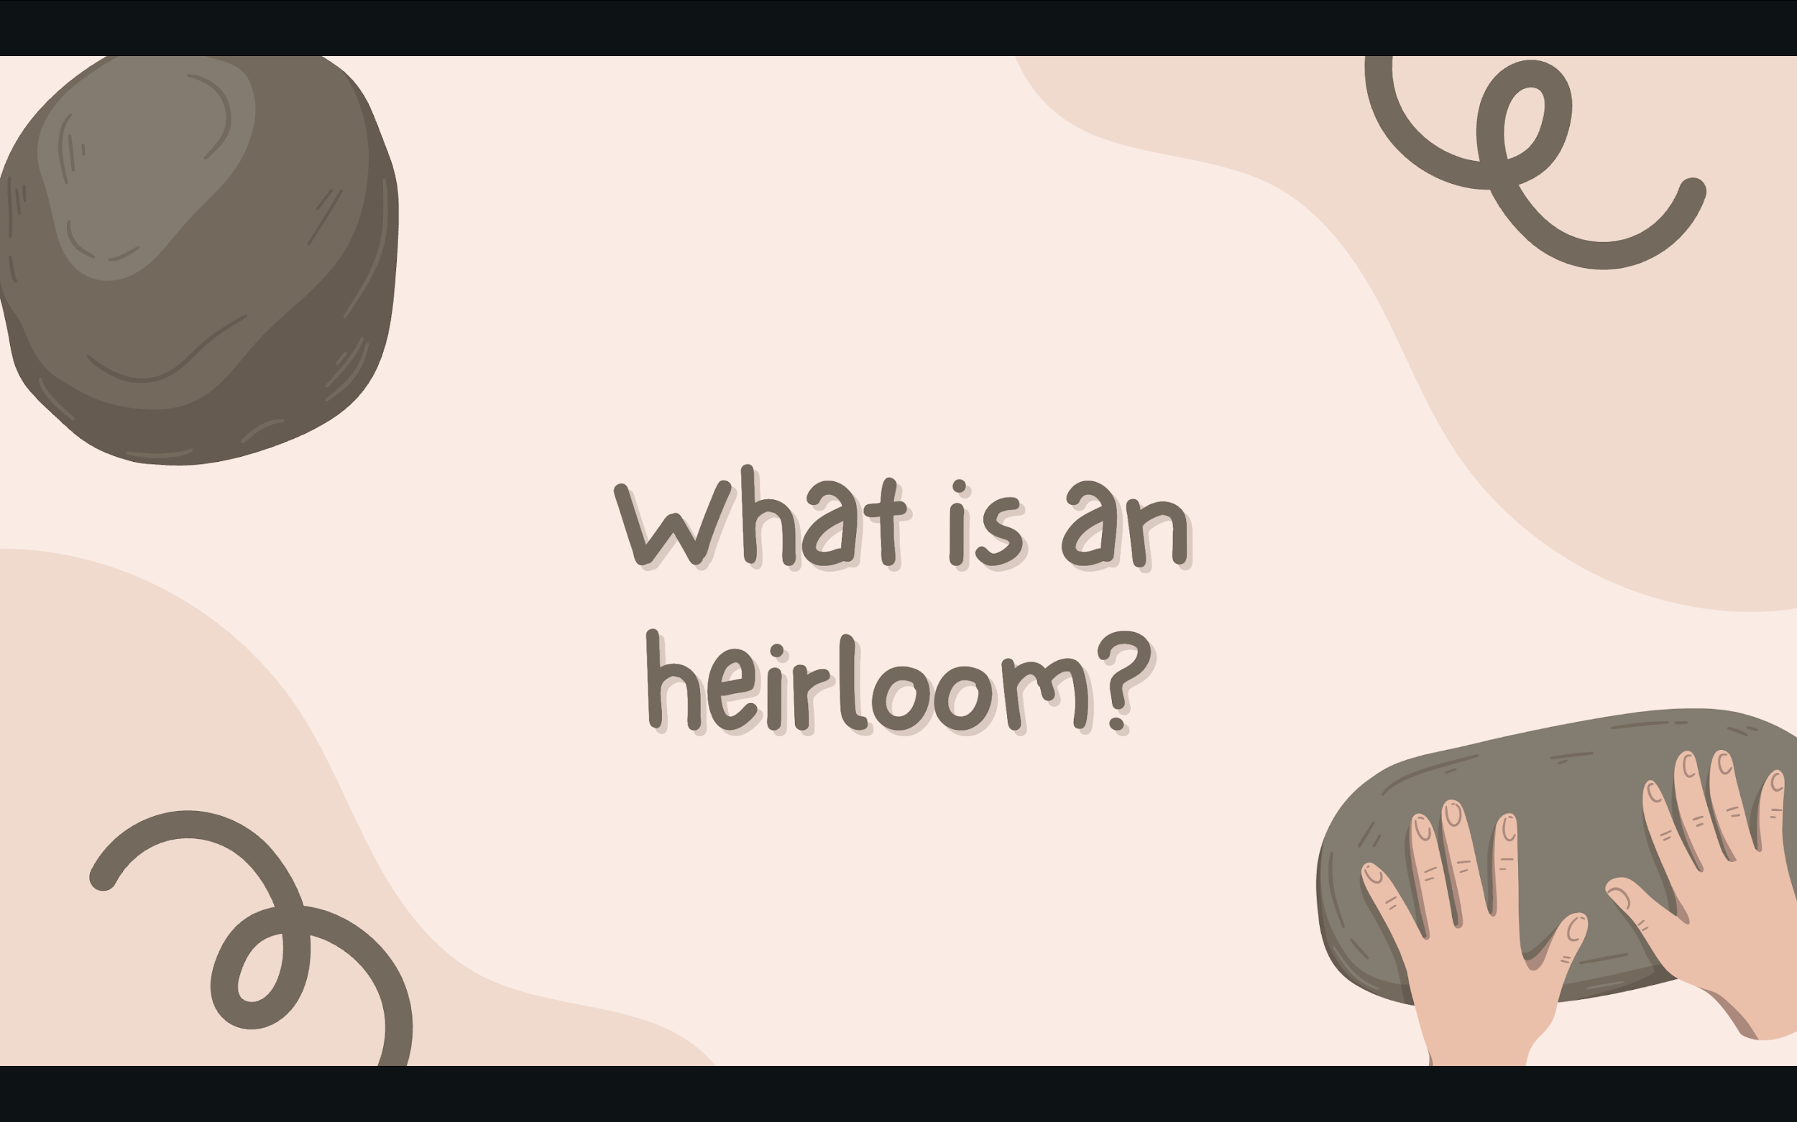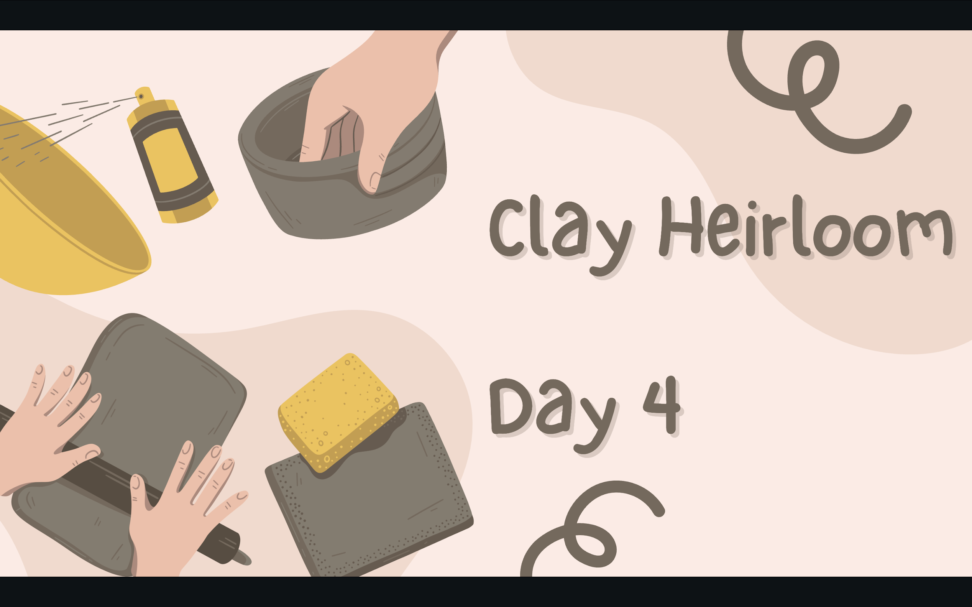

Assessment
Rubric for art experience 1- Clay Heirloom
Criteria | Unsatisfactory  (1 point) | Needs improvement  (2 points) | Satisfactory  (3 points) | Outstanding  (4 points)
Craftsmanship | Does not meet | Partially meets | Mostly meets | Meets/ Exceeds
Chose objects and symbols that have personal meaning | Does not meet | Partially meets | Mostyly meets | Meets/ Exceeds
Used the coil pot technique | Does not meet | Partially meets | Mostyly meets | Meets/ Exceeds
Participation and Effort | Does not meet | Partially meets | Mostyly meets | Meets/ Exceeds

References
Ayers, W. (2019). About becoming a teacher. Teachers College Press.
Buffington, M. L. (2014). Power play: Rethinking roles in the art classroom. Art Education, 67(4), 6–12. https://doi.org/10.1080/00043125.2014.11519277
Buffington & Bryant (2019) Changing Practice: Culturally Sustaining Pedagogy in Art Education, Art Education, 72:2, 20-25, DOI:10.1080/00043125.2019.1559587
Christi Belcourt. Christi Belcourt Art. (n.d.). https://christibelcourt.ca/pages/about
Created in Clay. Tejas > Caddo Fundamentals > The Caddo Pottery Tradition. (n.d.). https://www.texasbeyondhistory.net/tejas/clay/tradition.html
Jason Elliott Clark: Myths and legends. MAGDA. (2023, July 13). https://magdamt.org/traveling-exhibitions/exhibitproposalform/jason-elliot-clark-prints-from-the-mam-collection/
Kahwinhut Earles , C. (n.d.). About. Caddo Pottery. https://www.caddopottery.com/about
Makers, C. (2015, August 10). Caddo Pottery. https://contemporarymakers.blogspot.com/2015/08/caddo-pottery.html
Novak, K. (2025, June 28). If equity is a priority, UDL is a must. Cult of Pedagogy. https://www.cultofpedagogy.com/udl-equity/

